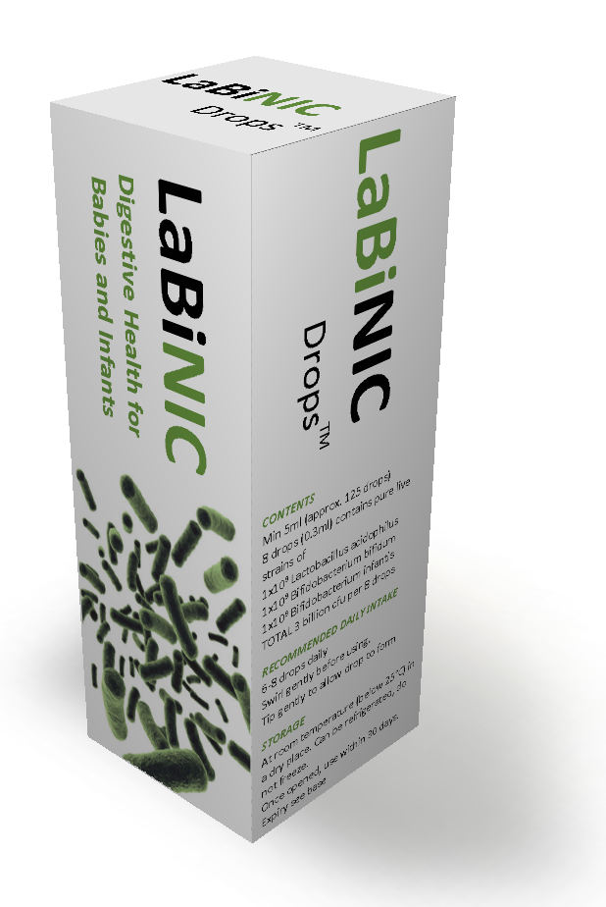
Labinic Probiotic Drops for Babies

Information for parents

Your views are most important and we want to keep you fully informed about how we plan to care for your baby. This leaflet explains some important feeding issues in premature babies including the use of probiotics.

We wish to inform you about a probiotic product called Labinic Drops® which we give to certain babies, with the aim of protecting your baby and improving their health.

What is different about feeding premature babies?

We know that premature babies tolerate milk best if it is introduced gradually. Until they are able to tolerate enough milk, we feed most premature babies with a special intravenous liquid feed called Parenteral Nutrition (“PN”) which contains amino acids, sugar, fat, vitamins and minerals to help your baby to grow.

Some babies find digesting milk difficult and take longer than others to manage this. Most babies remain well, but around 2-5% of very low birthweight babies can become unwell with a condition called ‘NEC’ (Necrotising EnteroColitis) in which there is inflammation of the gut.

Many babies who get NEC recover fully, but it can sometimes be serious, sometimes needs an operation, and can occasionally be life-threatening.

What can we do to try and prevent NEC?

Your choice in how you will feed your baby is one important factor. Breast milk is the best milk for your baby. It reduces the risks of bowel problems including NEC. Even small amounts of breast milk are important for your baby.

Early expression of breast milk starting as soon as possible after birth and ongoing frequent expression of breast milk are important for optimal early nutrition of your baby and successful lactation. We will support and encourage you if you choose to express breast milk. If you are unable to or choose not to express breast milk we will advise on the most suitable alternatives.

Probiotics

There is now very good evidence that giving preterm babies small amounts of ‘healthy’ live bacteria in their milk (like those bacteria found in live yoghurts and probiotic drinks that are now available in supermarkets) reduces the risk of NEC, including in babies receiving breast milk. These ‘healthy’ live bacteria are called probiotics.

Are Probiotics a standard treatment?

Using probiotics in babies has been standard treatment in many neonatal units worldwide for many years. A number of neonatal units in the UK give probiotics routinely to preterm babies, though it is not yet widespread practice in all.

What do we know about probiotics and babies?
Probiotics have been extensively studied in several thousand preterm babies. The evidence shows that probiotic bacteria (particularly Lactobacillus and Bifidobacteria bacteria combined together) help to reduce the chances of NEC by more than 50%, and also reduce deaths. This means that probiotics protect babies against NEC and improve their survival chances.

Probiotics also improve the tolerance of milk feeds. They may reduce gastro-oesophageal reflux, and may be used in more mature babies who have colic or pains after exposure to antibiotics. Some doctors and parents use probiotics routinely in babies to maintain healthy digestion.

Are there any risks of being given probiotics?

The studies show that probiotics are safe to give, even in the smallest babies. Rare cases of infection from giving the probiotic live bacteria have been reported but they are usually relatively minor and easy to treat. In the unlikely event that this happens we have antibiotics available that kill the probiotic bacteria.

How do we give probiotics?

Labinic Drops contain 3 different probiotics and has been designed for neonatal patients and infants. We plan to start giving your baby Labinic drops when they are tolerating a little milk, via the feeding tube. We will normally carry on giving Labinic with the milk feeds until your baby reaches around 34 weeks corrected age, or until their discharge/transfer, whichever is sooner. Sometimes we may consider Labinic drops to be suitable for more mature babies if they have received a lot of antibiotics for example, or if they are having feeding difficulties.

If your baby is transferred back to your local hospital before 34 weeks corrected age, because probiotics are not yet widely used in other UK neonatal units, it is possible that ongoing Labinic treatment will be not be available after transfer. This can be discussed as needed, as Labinic can be easily obtained.

Who should I ask if I have any queries?

The Doctors and Nurses on NICU should be able to answer any questions you might have about this or any other matters. There is also the supplier’s information webpage at www.biofloratech.com

We hope that the information in this leaflet has been useful and clear. If you think that the leaflet could be improved, then please do tell us.

Updated May 2017

